What follows is an itemized list on how a developer resource will create a New Project leveraging the Allstate MarketPlace

 | Instructions | Description / Comments
1 | Navigate to the AllState MarketPlace | https://marketplace.mgmt.allstate.com/  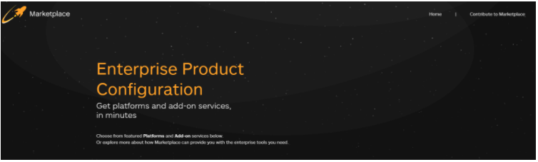
2 | Scroll Down to Until you see the following (Reference Screen Shot to the Right | 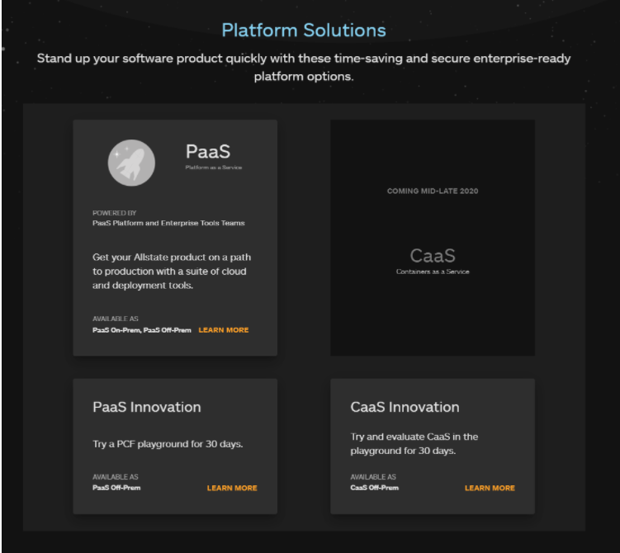
3 | Select the PaaS (Platform As A Service) | 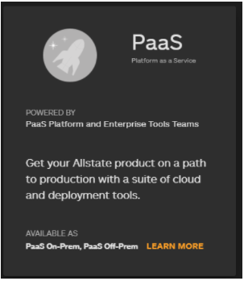
4 | Redirects you to the following ( Reference Screen-shot to the right )  Select "Create a New Product on PaaS" More Info Button | 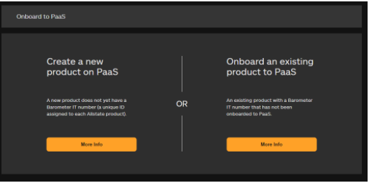
5 | Redirects you to the following ( Reference Screen-shot to the right )  Select Get Now Button | 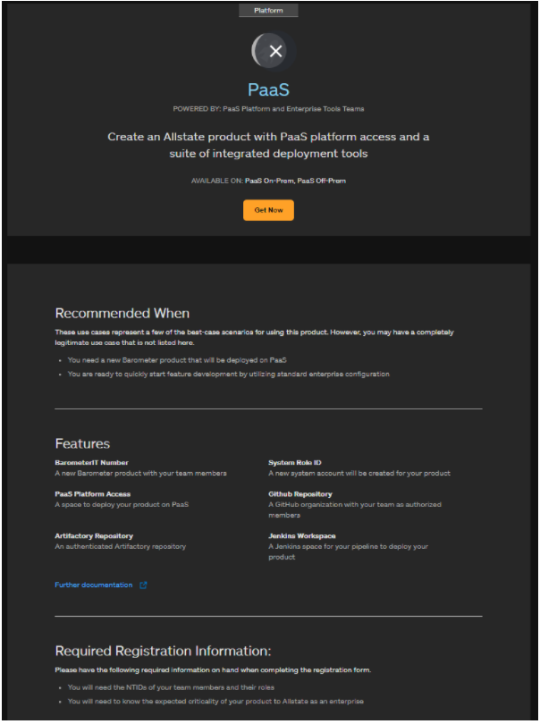
6 | Redirects you to the following ( Reference Screen-shot to the right )  Enter your Network Credentials | 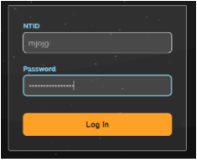
7 | Redirects you to the following ( Reference Screen-shot to the right )  Fill out the information as shown with the following exceptions  a. Name of Product  b. Name that will appear in GitHub, PCF, etc  c. System Role ID Name  This is restricted to a Maximum of 11 Characters after the "sys-" Prefix  d. Description  These values are specific to the project.  What is seen in the screen-shot to the right are examples reminiscent of a HELLO WORLD.  The formats would be the following:  "AB- insertYourValueHere-PCF"  "sys-insertYourValueHere" | 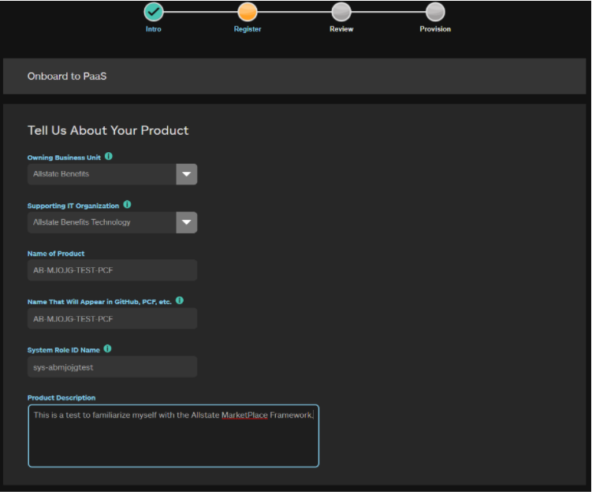
8 | Scroll Down to the following Sections ( Reference Screen-shot to the right )  Fill out the information as shown with the following exceptions  a. Owner  b. Product Manager  c. Developers  d. Additional Developers  Make certain to be aware of your team members and add the appropriate values within  this MarketPlace Section | 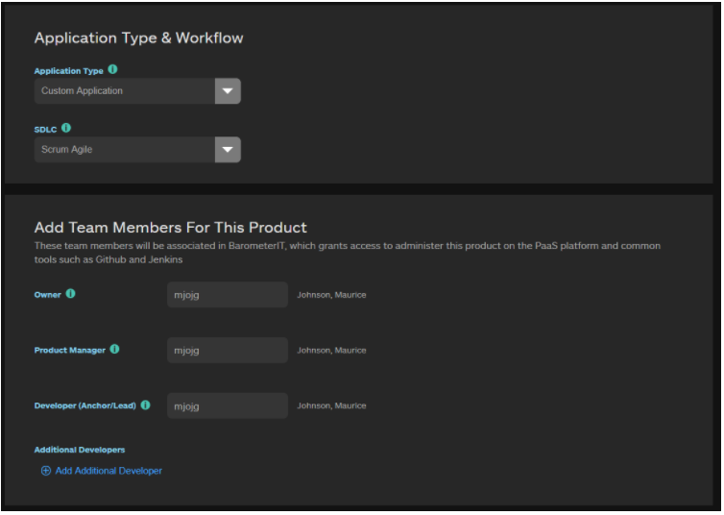
9 | Scroll Down to the following Sections ( Reference Screen-shot to the right )  Fill out the information as shown with the following exceptions  a. Enterprise Criticality Tier  ( Tier 9 has been chosen here however confirm with your Architect or Primary Engineer )  b. Kafka (Optional)  NOTE: For now "NO" has been selected with the understanding that KAFKA can be  added at a later time. What that effort looks like, I am unaware as  of this writing. | 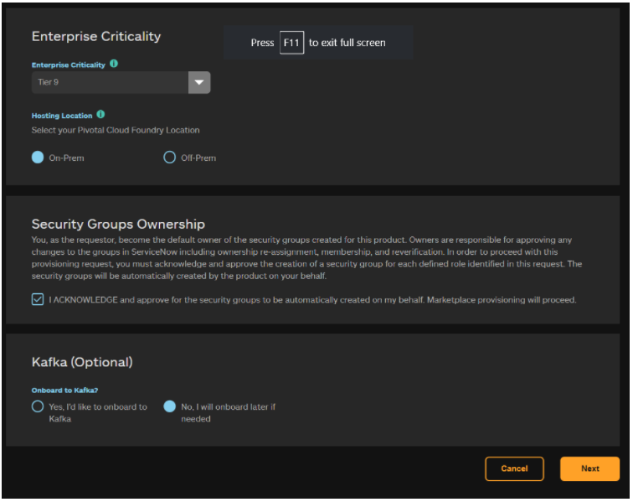
10 | Click the "NEXT" Button | Redirects you to the following ( Reference Screen-shot to the below )
11 | Review your Project Details. Take special note of the following:  a. System Role ID Name  b. Name of Product  c. Name that will appear in GitHub, PCF, et cetera  These values will be important at the time of configuring your Developer IDE as well as the locations for your GitHub Repository, your Jenkins Pipeline, your PCF Location, Web Services, Deployment Locations et cetera.  20210316: In Regards to Application Details, SDLC Value, it must be "Scrum Agile". This has been noted due to the following CompoZed Platform Documentation, for a Production Deployment, stating it must be changed to "XP Agile". Per Release Team this is outdated information, therefore incorrect.  https://docs.compozed.allstate.com/pages/deploying_apps/deploying_to_production.html | 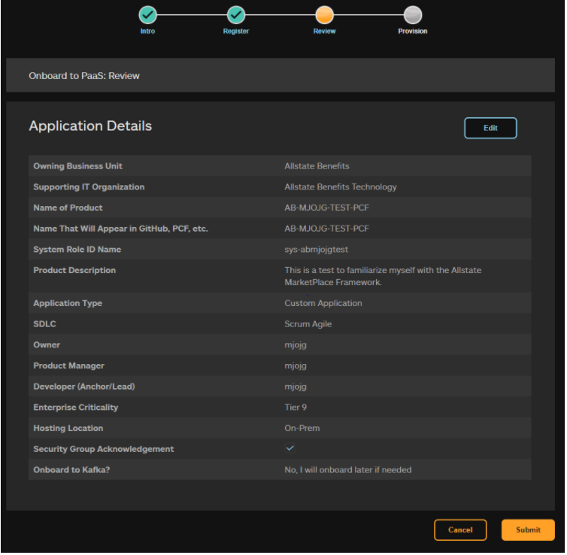
12 | Click the "SUBMIT" Button | Redirects you to the following ( Reference Screen-shot to the below )
13 | As the screen shot depicts the AllState MarketPlace is now generating the projects developer pipeline.  It will generate the following for the developer:  a. System Role ID  b.. BarometerIT Number  c. GitHub  d. Artifactory  e. PCF  f. Compliance Buddy Onboarding  g. Jenkins Pipeline  h. A series of emails will be received documenting the pipeline.  Pay special attention to the Emails that are generated. It will contain all of the pertinent informationfor the generated pipeline, in addition to a GENERATED PASSWORD, for the generated System Role ID. All information should be shared with your developers. They will require them when they spin up their Developer IDE (Integrated Development Environments) on their laptops.  ***Examples of the emails received have been provided in the next row of these instructions.*** | 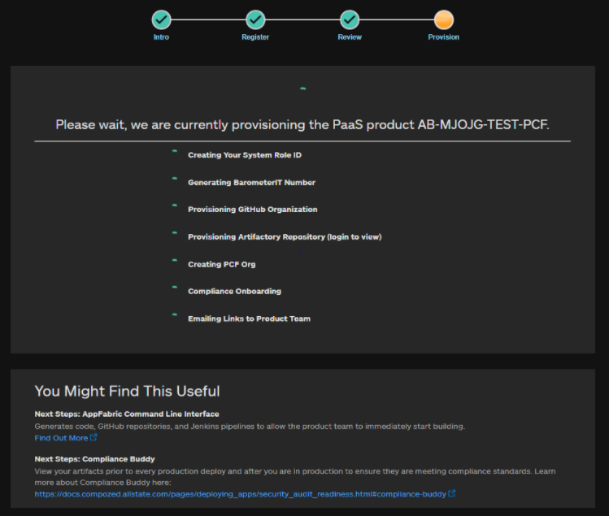
 | AllState MarketPlace Email Examples Received:
 | System Rold ID Password Generated Email:  This email is the "Holy Grail", it will contain the following Information:  a. System Role ID Generated Password  PLEASE Document this EMAIL or save it off to a place where you will not forget it. | InsertEmailhere
 | AllState MarketPlace Owner Email: | InsertEmailhere
 | Security Group BarameterIT Number Agreement Email: | InsertEmailhere
 | Series of Service NOW Tickets Processed: | InsertEmailhere
 | Marketplace Fulfillment: New product created on PaaS Email:  This email is the "Holy Grail", it will contain the following Information:  a. System Role ID  b. BarometerIT Number  c. GitHub Location  d. Artifactory Location  e. PCF Location  f. Compliance Buddy Onboarding  g. Jenkins Pipeline  And additional Next Steps, PLEASE Document this EMAIL or save it off to a place where you will not forget it. | InsertEmailhere
14 | Validate that the AllState MarketPlace has established your Developer Pipeline | Referencing the last Email You Have Received, Navigate to each PaaS Provisioned Project Link and Validate that it both works and the pipeline has been successfully established:  a. GitHub  b. Artifactory  c. PCF Organization  d. Jenkins  e. Compliance Buddy  ***Additional Steps if Any. In Particular, make certain that the Jenkins Pipeline has been established with the necessary boilerplate jobs and that they ran to success. There may be additional legwork as it is hard to determine what if any issues that may have been introduced along the way.  ***This set of instructions will continue to be a living document to compensate for any adjustments in the development pipeline or unforeseen alterations to the developer pipeline. ***
 | Congratulations you have officially set up your first AllState MarketPlace Developer Pipeline...

